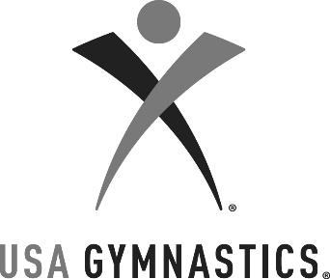
USA Gymnastics Wisconsin
State meet

March 23-25, 2018

2018 GRADUATING SENIORS

Coaches: Please fill out the information below and email it to WIstatemeet@midwesttwisters.com. Special recognition will be given to all the graduating seniors after their competitive season.

Gymnast Name:________________________________________
Level:__________________ Started Gymnastics at Age:________
Club:_________________________________________________
Coached By:___________________________________________

Accomplishments:
________________________________________________________________________________________________________________________________________________________________________________________________________________________________________________________________________________________________________________________________________________________________________________________________________________________________________________________________________________

Future Plans:
__________________________________________________________________________________________________________________________________________________________________________________________________________________________________________________________________________________________________

